Entity Framework Core

Lab 1: Understanding ORM with a Retail Inventory System

Output :

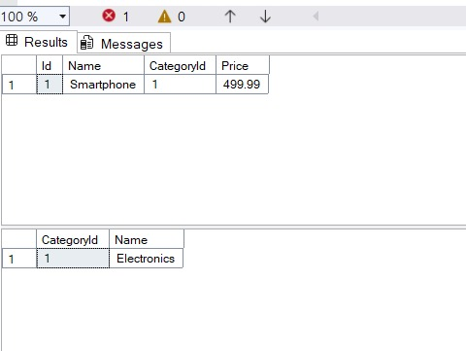

Lab 2: Setting Up the Database Context for a Retail Store

Output :

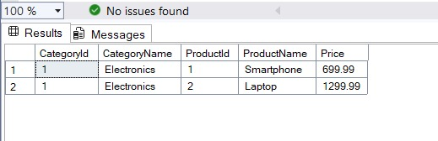

Lab 3: Using EF Core CLI to Create and Apply Migrations

Output :

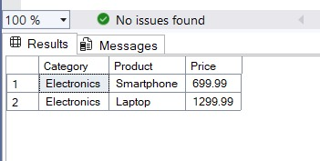

Lab 5: Retrieving Data from the Database

Output :

